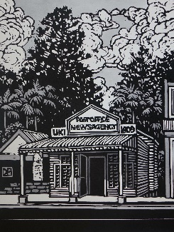
Uki Post Office

Image courtesy of David Preston

11 January 2019

ART POST UKI ANNOUNCES ITS FIRST EXHIBITION FOR 2019
"Horizons and Beyond" by DIETER IRVING

In 1971 Stokers Siding artist, Dieter Irving came to Australia with friends for an adventure. That adventure turned into a permanent stay and a lifelong love affair with the Australian bush, the light, the landscape and the big sky.
‘My love affair with the Australian bush began when I migrated from Germany. I instantly fell in love with the bush and light. I loved the expansion of the landscape and the big sky just blew my mind. I felt a freedom I never felt in the European landscape. The Australian landscape has never stopped seducing me.”
Dieter was born in 1945 in Austria and by 1965 he was enrolled at the Academy of Art in Mannheim where for one year he was in the master class of six students tutored by Expressionist artists Paul Bergner and Hans Meistermann. Since completing four years at the Academy he has been a professional artist and teacher both in Germany and in Australia
After migrating to Australia and settling into a whole new way of life in Rockhampton, which included marriage and children, Dieter held his first exhibition at the Hogarth Gallery in Sydney in 1976.
Many exhibitions and one man shows in Queensland have followed. In 1981 he won the Rockhampton Art Prize and in 1989, he exhibited at the Frankfurt Opera House in Germany (a complete resume is available).
In 2010 Dieter went on another painting adventure with fellow artist Bill Gannon called "In the Wake of Flinders and Westall'. Sponsored by Australian Geographic a group of artists followed the 1802 path along which landscape artist William Westall sketched the Queensland Coast. Footage of this expedition, shot by Dieter’s daughter Sarah, was broadcast by the ABC.
Dieter has another string to his bow as a set designer. His wife Penelope (Penny) Irving is currently the Murwillumbah Theatre Company’s Director and they collaborate on the all Company’s productions. They make an awesome team.
Dieter is thrilled to be having an exhibition at the Uki Post office, where he can introduce himself and some of his beautiful work.
“Horizons and Beyond” opens on Thursday 17th January 2019 and runs for six weeks.
Website www.artpostuki.com
Facebook #ArtPostUki
Gary Wall (Post Master, Art Post Uki) 0402 469 807 / (02) 6679 5101
Sue Kinneally 0435 030 114

